|  |  |
| --- | --- |
| **Title:** | **Window Lifter**  **SW Component < XXXXXXX >** |

|  |  |  |  |  |
| --- | --- | --- | --- | --- |
| **History** | | | | |
| **Issue status**  (Index) | **Maturity/Date**  (draft/invalid/valid)  (dd-mmm-yyyy) | **Author**  Department | **Check/Release**  Department | **Description** |
| 1.0 | Draft  04-0ct-09 | Miguel Garcia | Miguel Garcia | Creation of the document. |
| 2.0 | Draft  26-Oct-17 | Rodrigo Mortera | Rodrigo Mortera | Insert Diagrams. |
| 2.1 | Draft  27-Oct-17 | Rafael Sanchez | Rafael Sanchez | Add function descriptions.­­­­­­ |

**Table of Contents**

**1** **PURPOSE 3**

**2** **DEFINITIONS AND ABBREVIATIONS 3**

**3** **REALIZATION CONSTRAINTS AND TARGETS 3**

**4** **SW CONCEPTUAL DESIGN 3**

**5** **SW COMPONENT INTERNAL BREAKDOWN 4**

**5.1** **Functional Decomposition 4**

***5.2*** **Function *<Type> <function name> (type par 1, .., type par n)* 5**

***5.3*** **Function <Type*> <function name> (type par 1, .., type par n)* 5**

# Purpose

*This document explains how works every component and the details of the software.*

# Definitions and abbreviations

**Definitions**

|  |  |
| --- | --- |
| *BlueLed* | *Define to identify the port for the Blue Led* |
| *RedLed* | *Define to identify the port for the Red Led* |
| *GreenLed* | *Define to identify the port for the Green Led* |
| *UpButton* | *Define to identify the port for the push button 12* |
| *DownButton* | *Define to identify the port for the push button 13* |
| *LedBar_1* | *Define to identify the port for the Bar’s first Led* |
| *LedBar_2* | *Define to identify the port for the Bar’s secondary Led* |
| *LedBar_3* | *Define to identify the port for the Bar’s third Led* |
| *LedBar_4* | *Define to identify the port for the Bar’s fourth Led* |
| *LedBar_5* | *Define to identify the port for the Bar’s fifth Led* |
| *LedBar_6* | *Define to identify the port for the Bar’s sixth Led* |
| *LedBar_7* | *Define to identify the port for the Bar’s seventh Led* |
| *LedBar_8* | *Define to identify the port for the Bar’s eighth Led* |
| *LedBar_9* | *Define to identify the port for the Bar’s ninth Led* |
| *LedBar_10* | *Define to identify the port for the Bar’s tenth Led* |
| *WDOG_disable* |  |
| *PORT_init* |  |
| *SOSC_init_8MHz* |  |
| *SPLL_init_160MHz* |  |
| *NormalRUNmode_80MHz* |  |
| *LPIT0_init* |  |
| *lpit0_ch0_flag_counter;* |  |
| *lpit0_ch1_flag_counter* |  |
| *clear_GPIO* |  |
| *Push_UpButton* |  |
| *validation_10ms* |  |
| behavior_UP |  |
| flag |  |
| antiPinch |  |
| Push_DownButton |  |
| timer |  |
| behavior_Down |  |
| Push_DownButton |  |
| **OneTouch_UP** |  |
| temp |  |
| switch_flag |  |
| Manual_up |  |
| Push_Antipinch |  |
| clear_Leds |  |
| **OneTouch_Down** |  |
| Manual_down |  |
| validation_500ms |  |
|  |  |

**Nombre de tus funciones**

**Variables**

**Abbreviations**

|  |  |
| --- | --- |
| CH1 | Channel1 |
| CH2 | Channel2 |
| R&D | Research and Develop |

**References**

|  |  |  |
| --- | --- | --- |
| **N°** | **Document name** | **Reference** |
| *1*  *2*  *2* | *USER_GUIDE_S32K144*  [***S32K14x Series Reference Manual***](https://www.nxp.com/docs/en/reference-manual/S32K-RM.pdf)  [***S32K1xx Data Sheet***](https://www.nxp.com/docs/en/data-sheet/S32K-DS.pdf) | <https://www.nxp.com/products/microcontrollers-and-processors/arm-based-processors-and-mcus/s32-automotive-processors-and-microcontrollers/32-bit-automotive-general-purpose-microcontrollers:S32K?tab=Documentation_Tab> |
|  |  |  |
|  |  |  |
|  |  |  |

# Realization constraints and targets

Limitantes y objetivos

The objective of the task is to achieve to lift and down a window car simulated by 10 led bar of red color regarding to the customer request. The development of the project must be on the Development Kit Platform S32K144EVB NXP microcontroller provided by Continental R&D.

# SW Conceptual design

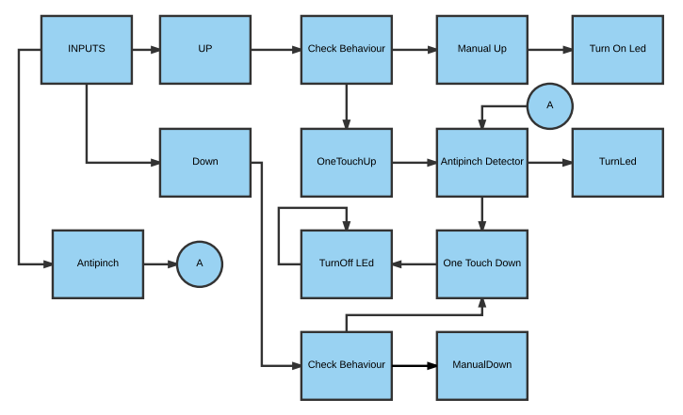

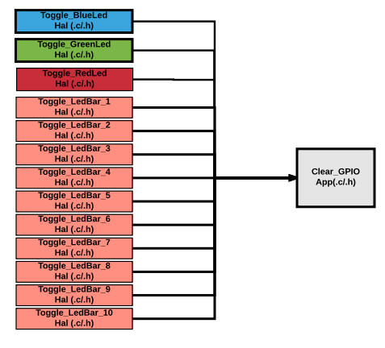

1. **SW Component internal breakdown**

* **Validate_Antipinch function to validate the push in Push_Antipinch function in App.**
* **Validate_UpButton function to validate the push in Push_UpButton function in App.**
* **Validate_DownButton function works to validate the push in Push_DownButton function in App.**

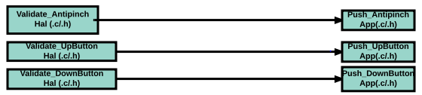

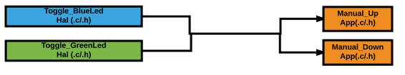

* **Toggle functions execute the functionality to turn on or turn off the led’s, called by either Manual_Up or Manual_Down functions in App.**

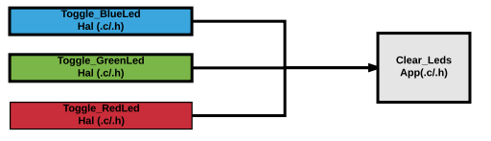

* **The Clear_Leds function Works to condition if the leds should to be on or off.**



* **The Clear_GPIO only Works to clear all the inputs and outputs used in the program.**

## Completed Diagram

## 

## 5.1 Functional Decomposition

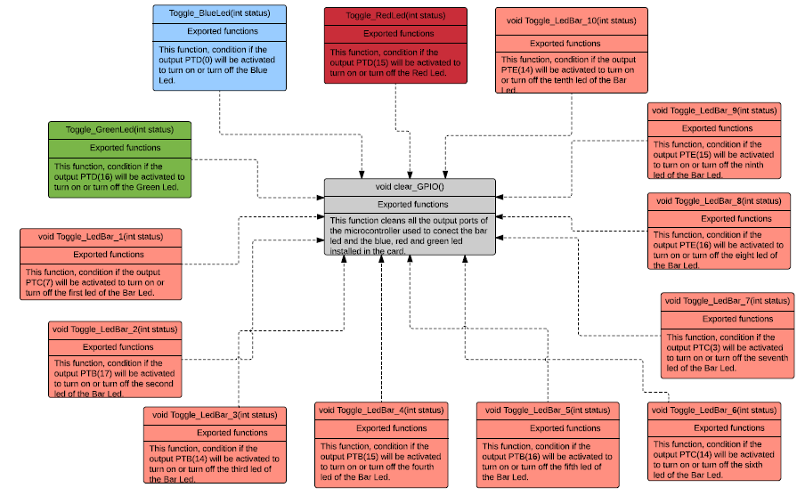*Overview of functions and their dependencies shown by a Static Function Tree*

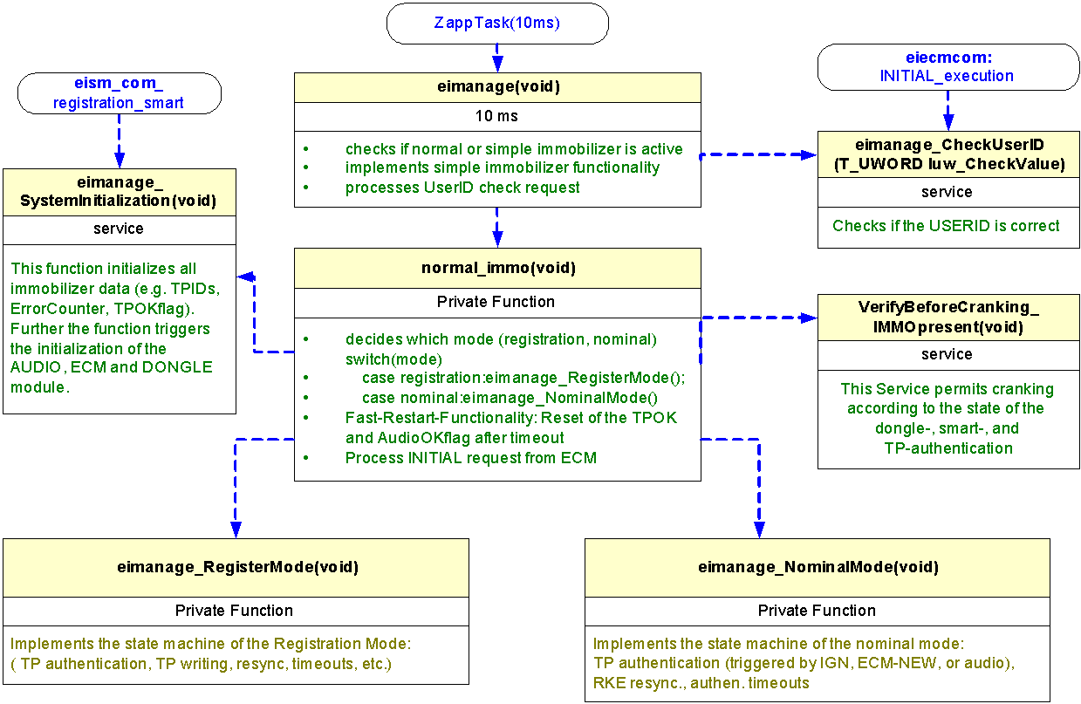

**Function Description and Dynamic Behavior**

*Provide detailed static and dynamic description of all functions of the SW Component.   
Functions which are defined in other SW Components shall only be referenced in the external interface description!  
The signature description shall be done inside the function header in the source code.  
  
For each function, the following section should be copied*

## Function *<Type> <function name> (type par 1, .., type par n)*

|  |  |
| --- | --- |
| **Description** | *Brief description of the function behavior and useful remarks* |
| **Parameter 1** <input| output| inout> | *Give an explanation if the parameter shall be checked by the user, or if a check is implemented in the function here* |
| **Parameter 2..n** |  |
| **Return Value** |  |
| **Precondition** | e.g. Function can only be called in a certain state, SW component is initialized Relation between input parameters where applicable (Input for Module Test) |
| **Post condition** | *e.g. specific State change e.g. car is locked, EEPROM Values written, Relation between output parameters where applicable* |
| **Error Conditions** |  |

**Dynamic Behavior**

State Chart1, Flow Chart1

## Function void Manual_Up()

|  |  |
| --- | --- |
| **Description** | Ascending Turn on the Led Bar using a switch statement, the Led number is proportional with switch_flag value. |
| **Precondition** |  |
| **Post condition** |  |
| **Error Conditions** |  |

**Dynamic Behavior**

State Chart1, Flow Chart1, Nassi Shneiderman

## Function void Manual_Down()

|  |  |
| --- | --- |
| **Description** | Descending Turn on the Led Bar using a switch statement, the Led number is proportional with switch_flag value. |
| **Precondition** |  |
| **Post condition** | *e.g. specific State change e.g. car is locked, EEPROM Values written, Relation between output parameters where applicable* |
| **Error Conditions** |  |

**Dynamic Behavior**

State Chart1, Flow Chart1, Nassi Shneiderman

## Function int Push_UpButton()

|  |  |
| --- | --- |
| **Description** | Calls Validate_UpButton() function, to know if the Validate_UpButton() is true or false |
| **Parameter 1** <input| output| inout> | *Give an explanation if the parameter shall be checked by the user, or if a check is implemented in the function here* |
| **Parameter 2..n** |  |
| **Return Value** | 1 , 0 |
| **Precondition** | e.g. Function can only be called in a certain state, SW component is initialized Relation between input parameters where applicable (Input for Module Test) |
| **Post condition** | *e.g. specific State change e.g. car is locked, EEPROM Values written, Relation between output parameters where applicable* |
| **Error Conditions** |  |

**Dynamic Behavior**

State Chart1, Flow Chart1, Nassi Shneiderman

## Function int Push_UpDown()

|  |  |
| --- | --- |
| **Description** | Calls Validate_DownButton() function, to know if the Validate_DownButton() is true or false |
| **Parameter 1** <input| output| inout> | *Give an explanation if the parameter shall be checked by the user, or if a check is implemented in the function here* |
| **Parameter 2..n** |  |
| **Return Value** | 1 , 0 |
| **Precondition** | e.g. Function can only be called in a certain state, SW component is initialized Relation between input parameters where applicable (Input for Module Test) |
| **Post condition** | *e.g. specific State change e.g. car is locked, EEPROM Values written, Relation between output parameters where applicable* |
| **Error Conditions** |  |

**Dynamic Behavior**

State Chart1, Flow Chart1, Nassi Shneiderman

## Function int Push_Antipinch()

|  |  |
| --- | --- |
| **Description** | Calls Validate_Antipinch() function, to know if the Validate_Antipinch() is true or false |
| **Parameter 1** <input| output| inout> | *Give an explanation if the parameter shall be checked by the user, or if a check is implemented in the function here* |
| **Parameter 2..n** |  |
| **Return Value** | 1 , 0 |
| **Precondition** | e.g. Function can only be called in a certain state, SW component is initialized Relation between input parameters where applicable (Input for Module Test) |
| **Post condition** | *e.g. specific State change e.g. car is locked, EEPROM Values written, Relation between output parameters where applicable* |
| **Error Conditions** |  |

**Dynamic Behavior**

State Chart1, Flow Chart1, Nassi Shneiderman

## Function void default_Leds(int led)

|  |  |
| --- | --- |
| **Description** | Using int led, with a switch statement, select case 0,1,2,3 and default.  case 0 → Turn off Blue, Green and Red Led.  case 1 → Turn off Blue.  case 2 → Turn off Green.  case 3 → Turn on Red.  default → Turn on Blue, Green and Red Led. |
| **Parameter 1** <input| output| inout> | input int led |
| **Parameter 2..n** |  |
| **Return Value** | void |
| **Precondition** | e.g. Function can only be called in a certain state, SW component is initialized Relation between input parameters where applicable (Input for Module Test) |
| **Post condition** | *e.g. specific State change e.g. car is locked, EEPROM Values written, Relation between output parameters where applicable* |
| **Error Conditions** |  |

**Dynamic Behavior**

State Chart1, Flow Chart1, Nassi Shneiderman

## Function void clear_GPIO()

|  |  |
| --- | --- |
| **Description** | Turn off Blue Led, Green Led, Red Led and Led Bar |
| **Parameter 1** <input| output| inout> |  |
| **Parameter 2..n** |  |
| **Return Value** | void |
| **Precondition** | e.g. Function can only be called in a certain state, SW component is initialized Relation between input parameters where applicable (Input for Module Test) |
| **Post condition** | *e.g. specific State change e.g. car is locked, EEPROM Values written, Relation between output parameters where applicable* |
| **Error Conditions** |  |

**Dynamic Behavior**

State Chart1, Flow Chart1, Nassi Shneiderman

## Function void timer();

|  |  |
| --- | --- |
| **Description** | When 1ms has occurred, increment lpit0_ch1_flag_counter variable. |
| **Parameter 1** <input| output| inout> |  |
| **Parameter 2..n** |  |
| **Return Value** | void |
| **Precondition** | The LPIT_MSR_TIF1_MASK timer should be configured and initialized |
| **Post condition** | The LPIT_MSR_TIF1_MASK timer has been cleared |
| **Error Conditions** |  |

**Dynamic Behavior**

State Chart1, Flow Chart1, Nassi Shneiderman

## Function int validation_10ms();

|  |  |
| --- | --- |
| **Description** | Check when lpit0_ch1_flag_counter is equal or higher to 10. This mean that 10 ms are occurred. |
| **Parameter 1** <input| output| inout> |  |
| **Parameter 2..n** |  |
| **Return Value** | int 1,0 |
| **Precondition** | The LPIT_MSR_TIF1_MASK timer should be configured and initialized |
| **Post condition** |  |
| **Error Conditions** |  |

**Dynamic Behavior**

State Chart1, Flow Chart1, Nassi Shneiderman

## Function int validation_500ms();

|  |  |
| --- | --- |
| **Description** | Check when lpit0_ch1_flag_counter is equal or higher to 500. This mean that 500 ms are occurred. |
| **Parameter 1** <input| output| inout> |  |
| **Parameter 2..n** |  |
| **Return Value** | int 1,0 |
| **Precondition** | The LPIT_MSR_TIF1_MASK timer should be configured and initialized |
| **Post condition** |  |
| **Error Conditions** |  |

**Dynamic Behavior**

State Chart1, Flow Chart1, Nassi Shneiderman

## Function int validate_UpButton();

|  |  |
| --- | --- |
| **Description** | Check if PORT C12 value is in High or Low and returns 1 if is High and 0 if is Low |
| **Parameter 1** <input| output| inout> |  |
| **Parameter 2..n** |  |
| **Return Value** | int 1,0 |
| **Precondition** | The PORTD C12 should be configured as input |
| **Post condition** |  |
| **Error Conditions** |  |

**Dynamic Behavior**

State Chart1, Flow Chart1, Nassi Shneiderman

## Function int validate_DownButton();

|  |  |
| --- | --- |
| **Description** | Check if PORT C13 value is in High or Low and returns 1 if is High and 0 if is Low |
| **Parameter 1** <input| output| inout> |  |
| **Parameter 2..n** |  |
| **Return Value** | int 1,0 |
| **Precondition** | The PORTD C13 should be configured as input. |
| **Post condition** |  |
| **Error Conditions** |  |

**Dynamic Behavior**

State Chart1, Flow Chart1, Nassi Shneiderman

## Function int validate_Antipinch();

|  |  |
| --- | --- |
| **Description** | Check if PORT E13 value is in High or Low and returns 1 if is High and 0 if is Low |
| **Parameter 1** <input| output| inout> |  |
| **Parameter 2..n** |  |
| **Return Value** | int 1,0 |
| **Precondition** | The PORTD E13 should be configured as input. |
| **Post condition** |  |
| **Error Conditions** |  |

**Dynamic Behavior**

State Chart1, Flow Chart1, Nassi Shneiderman

## Function void Toggle_BlueLed(int status);

|  |  |
| --- | --- |
| **Description** | Write in PORT D0:  - High if int status = 1.  - Low if int status = 0. |
| **Parameter 1** <input| output| inout> | Input int status |
| **Parameter 2..n** |  |
| **Return Value** | void |
| **Precondition** | The PORTD D0 should be configured as output. |
| **Post condition** |  |
| **Error Conditions** |  |

**Dynamic Behavior**

State Chart1, Flow Chart1, Nassi Shneiderman

## Function void Toggle_RedLed(int status);

|  |  |
| --- | --- |
| **Description** | Write in PORT D15:  - High if int status = 1.  - Low if int status = 0. |
| **Parameter 1** <input| output| inout> | Input int status |
| **Parameter 2..n** |  |
| **Return Value** | void |
| **Precondition** | The PORTD D15 should be configured as output. |
| **Post condition** |  |
| **Error Conditions** |  |

**Dynamic Behavior**

State Chart1, Flow Chart1, Nassi Shneiderman

## Function void Toggle_GreenLed(int status);

|  |  |
| --- | --- |
| **Description** | Write in PORT D16:  - High if int status = 1.  - Low if int status = 0. |
| **Parameter 1** <input| output| inout> | Input int status |
| **Parameter 2..n** |  |
| **Return Value** | void |
| **Precondition** | The PORTD D16 should be configured as output. |
| **Post condition** |  |
| **Error Conditions** |  |

**Dynamic Behavior**

State Chart1, Flow Chart1, Nassi Shneiderman

## Function void Toggle_LedBar_#(int status);

|  |  |  |
| --- | --- | --- |
| **Description** | Write High or Low in Led number # | |
| LedBar_1  Write in PORT C7:  - High if int status = 1.  - Low if int status = 0.  LedBar_2  Write in PORT B17:  - High if int status = 1.  - Low if int status = 0.  LedBar_3  Write in PORT B14:  - High if int status = 1.  - Low if int status = 0.  LedBar_4  Write in PORT B15:  - High if int status = 1.  - Low if int status = 0.  LedBar_5  Write in PORT B16:  - High if int status = 1.  - Low if int status = 0. | LedBar_6  Write in PORT C14:  - High if int status = 1.  - Low if int status = 0.  LedBar_7  Write in PORT C3:  - High if int status = 1.  - Low if int status = 0.  LedBar_8  Write in PORT E16:  - High if int status = 1.  - Low if int status = 0.  LedBar_9  Write in PORT E15:  - High if int status = 1.  - Low if int status = 0.  LedBar_10  Write in PORT E14:  - High if int status = 1.  - Low if int status = 0. |
| **Parameter 1** <input| output| inout> | Input int status | |
| **Parameter 2..n** |  | |
| **Return Value** | void | |
| **Precondition** | Should be configured as output: | |
| PORT C7  PORT B17  PORT B14  PORT B15  PORT B16 | PORT C14  PORT C3  PORT E16  PORT E15  PORT E14 |
| **Post condition** |  | |
| **Error Conditions** |  | |

**Dynamic Behavior**

State Chart1, Flow Chart1, Nassi Shneiderman